### **CATEGORIES OF SOFTWARE DEFECT:**

### **What is a Defect/Bug:**

* A software bug arises when the expected result don't match with the actual results
* It can also be error, flaw, failure, or fault in a computer program. Most bugs arise from mistakes and errors made by developers, architects.

**Categories of Software Defect/Bug:**

Software Defect is some kind of error, flaw or some kind of mistake from the development team which prevent the software from the smooth working.

It directly affect software quality, software quality is some thing how smooth and reliable your software is.

**Categories of defects:**

Categories of defects are:

* Errors of commissions,
* Errors of omissions,
* Errors of clarity, and
* Error of speed and capacity.

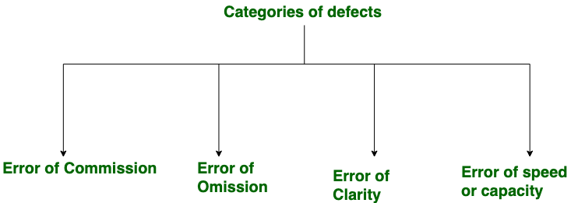

**1. Errors of Commission:**  
 Commission means instruction or some kind of command given. Now the error in commission means the error in made in command or instruction. For example, suppose I wrote a loop which “I was trying to run 10 times but I command it to run more than 10 times by mistake this is the error of commission.”

**2.Errors of Omissions:**

As name is already describing error of omission is some thing which happens accidentally. Omission word means something left out or executed. Practical most common example of this error is suppose we make a function in programming “open its bracket but forget to close at the end.”

**3.Error of Clarity:**

The most common error in the natural languages. “This error happens due to miss understanding between the developer and client.” It travels most of the time from the requirements to the software.

**4.Error of Speed or Capacity:**

The name of the error is itself enough I think to tell about it this error. Your software is working fine but not working in the required time this is the error of speed. When it comes to capacity it can be relevant to memory. For example, “a small integer is declared where the long integer was required.”

### **Some basic types of Defects in Software Testing:**

There are some kind of Defects:

* Design Defects
* Command Defects
* Boundary Value Defects
* Error Handling Defects
* Multithreading Defects
* Security Defect
* Interface Defects
* Priority of Defects
* Extra Defects
* Wrong Defects
* Missing Defects

**1.Design Defects:**

The algorithms, login and data elements, module interface, the external software and hardware UI descriptions should be correctly designed. The incompatible or incorrectly designed modules lead to defects in the system.

**2.Command Defects:**

An error in the sequences and logic is known as control flow error or command error. The reasons for such defects are missing command, wrong algorithm, incorrect data and code errors.

#### **3.Boundary Value Defects:**

In case the login page is logging in by giving the passport length to 16 characters in the place of 15 characters, then the defect is the boundary value defect.

**4.Error Handling Defects:**

The flow should indicate the instruction in the popup message for the mandatory fields to alert the users for incorrect information.

#### **5.Multithreading Defects:**

Executing or running multiple tasks at the time. Complex debugging is possible in the multiple threading process. It may also lead to a system crash/failure due to the condition in deadlock.

#### **6.Security Defect:**

The defects will be different by their nature of the risks. These defects are weaknesses allowing for a potential security attack.

**7.Interface Defects:**

The defects in the interactions of the software and the users. Some of the interfaces in the different kinds of forms are complicated interfaces, unclear interfaces and platform based interfaces.

**8.Priority of Defects:**

* The impact of the bug of an application should be described.
* It is the order of priority which the developer will resolve the defects.
* The Priority can be changed based on the comparison with other defects.
* At the time of UAT, defects are fixed according to the priority.

Priority can be classified as follow as:

Immediate/Critical

**9.Extra Defects:**

This is usually issued from the project specification without the knowledge in the documentation, but it also may be requested by the end users. It is considered a defect as it does not meet the existing requirements.

**10.Wrong Defects:**

These defects arose due to the misunderstanding within the project team, client and non clearance of project documents. The falsely performed requirements come under wrong defects.

**11.Missing Defects:**

A feature that is not implemented according to the specifications which means the team has not noted the clients requirements properly.